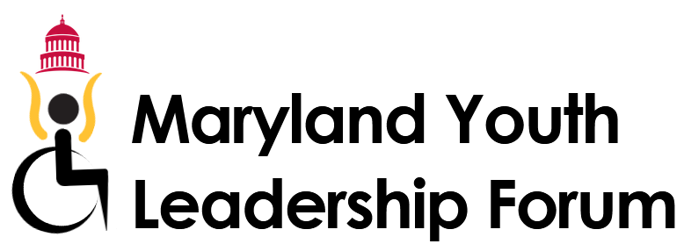
Open to: Maryland Students with disabilities in their last two years of high school
Cost: The forum is FREE for all of our participants
Date: June 26th to 28th 2023
Location: Towson University
Deadline to apply: March 3rd
Interviews: Danielle Bustos, Maryland Youth Leadership Coordinator will contact applicants about scheduling interviews.
About Youth Leadership Forum (YLF)
- Learn about assistive technology and how it can help gain independence
- Participate in the IL-stations, living in a college dorm, and other social activities.
- Meet people with disabilities who serve various roles in the community.
- Learn about how to give a testimony in front of a committee.
- Meet alumni and other students from the state of Maryland.
- Meet Your State representatives.
For more information contact, Danielle Bustos at 240-898-2189/ dbustos@innow.org
or Shannon Minnick at 240-638-0070/sminnick@innow.org
This project was supported, in part by grant number CFDA 93.630, from the U.S. Administration for Community Living, Department of Health and Human Services, Washington, D.C. 20201. Grantees undertaking projects with government sponsorship are encouraged to express freely their findings and conclusions. Points of view or opinions do not, therefore, necessarily represent official ACL policy.

